Reading #3: New Media Art: Introduction

According to the author,"New Media art" refers to works like interactive multimedia installations, virtual reality environments, and web-based art that were made using digital technology. It involves projects that make use of emerging media technologies and are concerned with the cultural, political, and aesthetic possibilities of these tools. The author places New Media Art at the intersection of two broader categories: "Art and Technology," which encompasses practices involving new but not necessarily media-related technologies, and "Media art," which includes art forms like video art and experimental film that incorporate media technologies no longer considered new by the 1990s. New Media Art is defined by its ability to repurpose and redefine technologies for critical or experimental purposes, often challenging the conventional uses and perceptions of these technologies.From my point of view, New Media Art continues to embrace a wide array of digital and emerging technologies. Artists now work with virtual reality, augmented reality, artificial intelligence, 3D printing, blockchain, and even quantum computing. These technologies provide a broader canvas for artistic expression.What’s more, Audience participation is often central to the art's meaning. Interaction including haptic feedback, gesture recognition, and immersive experiences that engage multiple senses. Also,Artificial intelligence has become a powerful tool for artists. AI is used for creating generative art, where algorithms produce art autonomously. Like the last experience with cclab going to the Team lab,one of the room that represents how the butterflies changing with the audience’s gesture,they will appear if we put the hands on the wall and appear if we keep our feet on the floor to block the butterflies.

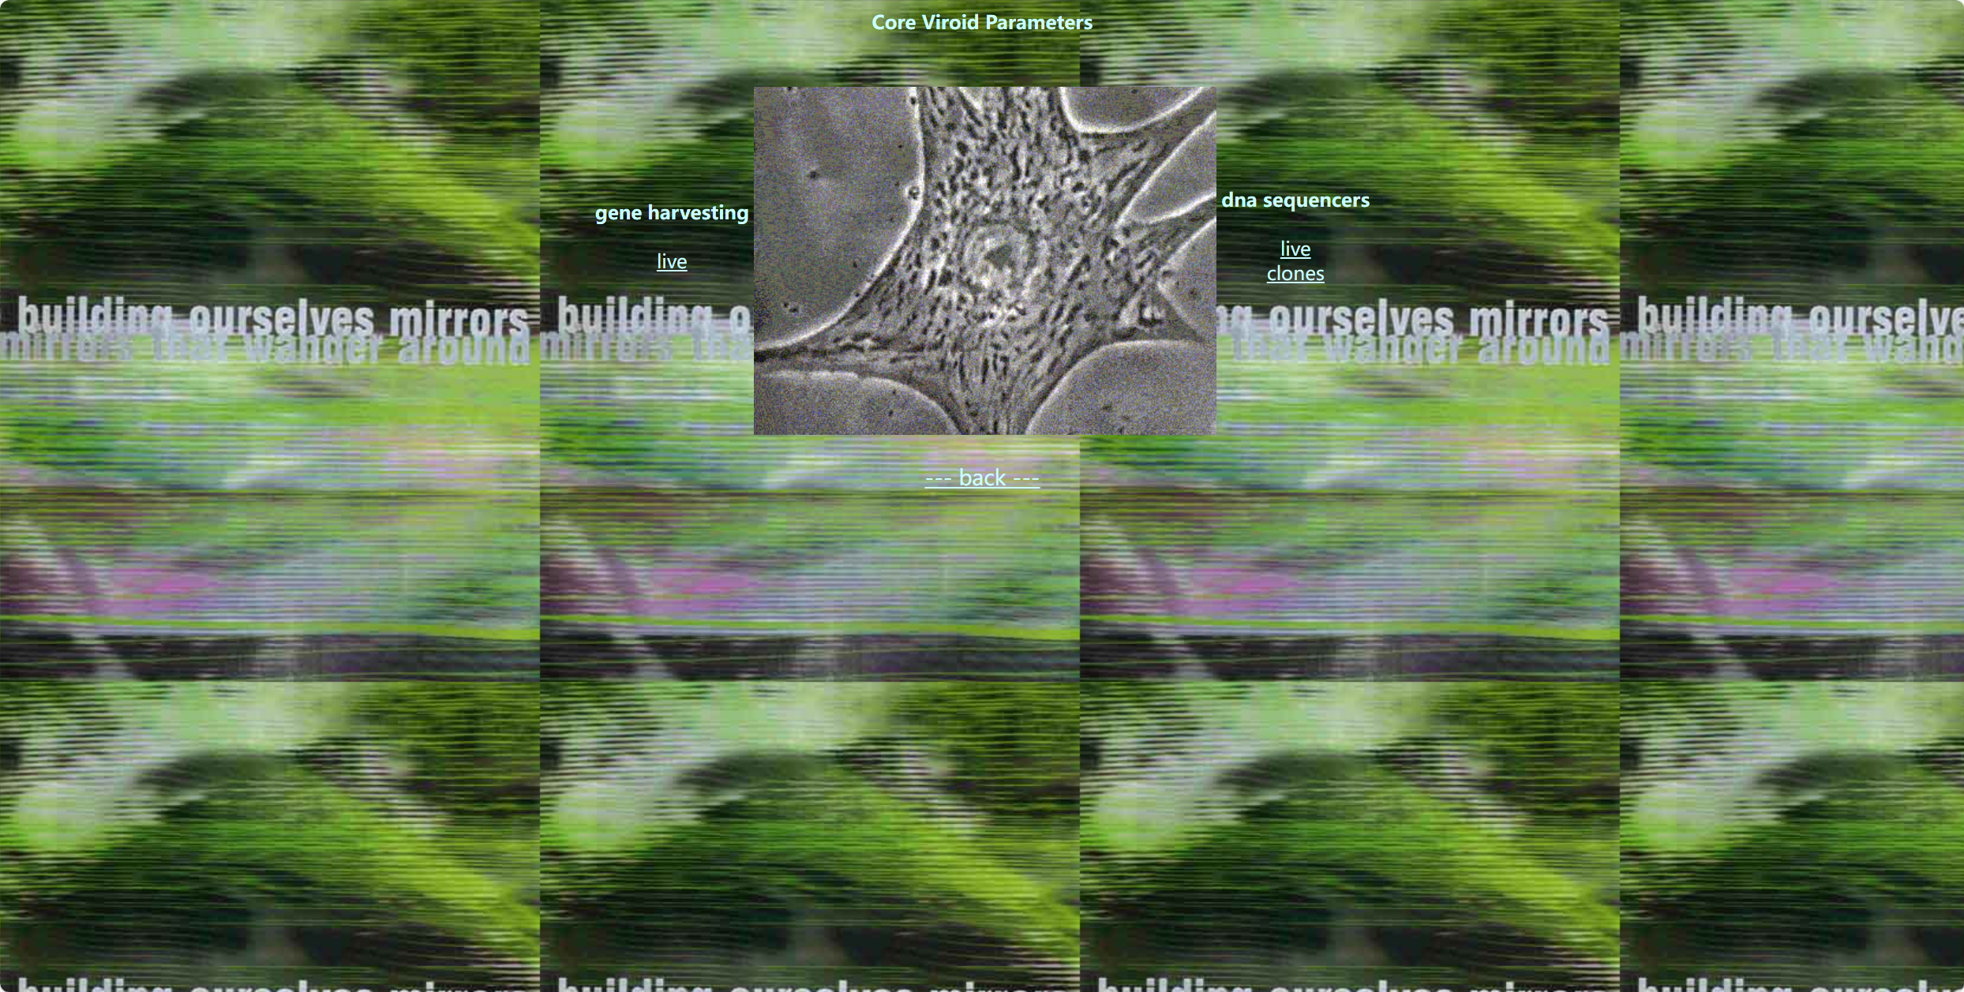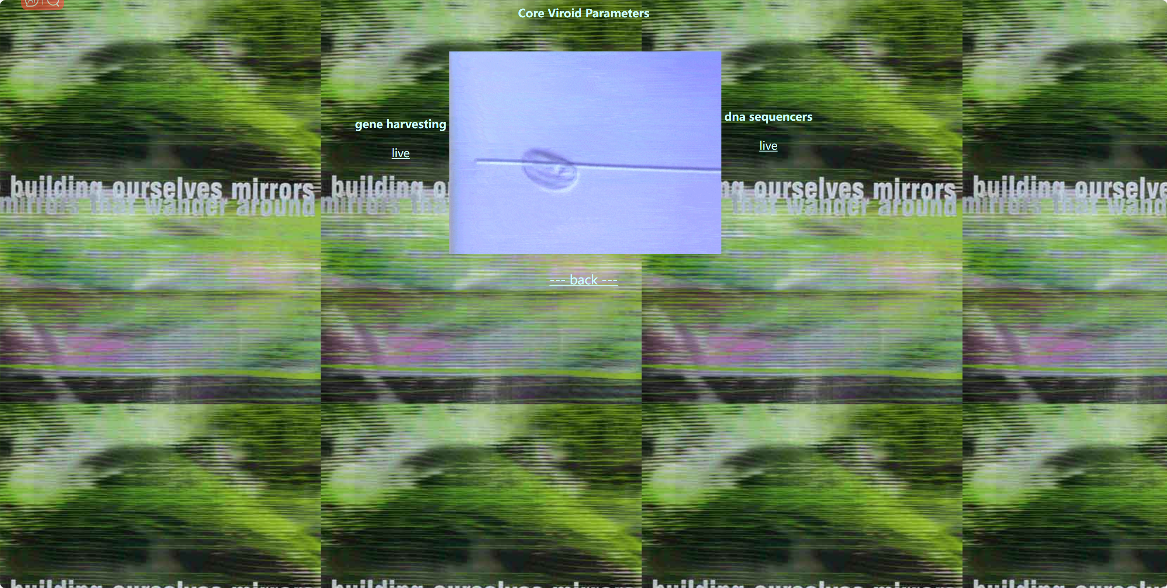

(2001_

Diane Ludin's "Genetic Response System 3.0" is an artwork that is part of a series known as the "Genetic Response Systems." Diane Ludin is an artist who explores the intersection of art, science, and technology. Her work often delves into genetics and the implications of biotechnology in contemporary society. As a digital artwork or interactive installation, it likely offers viewers an immersive experience that prompts contemplation of the ethical, social, and scientific implications of biotechnology and genetic manipulation. In Ludin's works, interactivity and digital media are common tools for engaging the audience in a dialogue about the complexities of genetics, identity, and the rapidly evolving landscape of technology. The "3.0" in the title implies an ongoing evolution, suggesting that this work is part of a dynamic series that reflects the continual progression of genetic research and its implications on our lives.

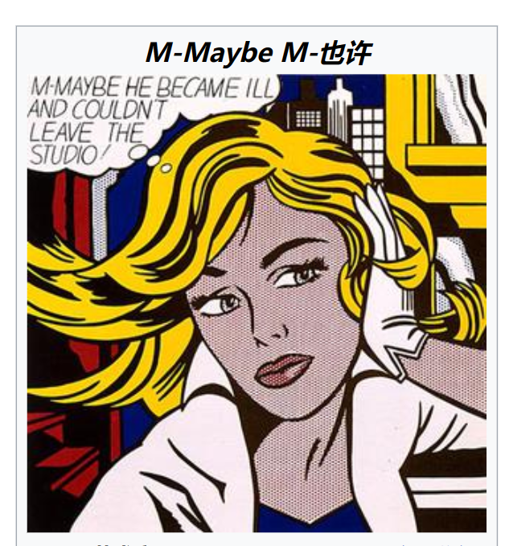

Roy Lichtenstein's "M-Maybe" is a well-known work created in 1965 as part of his iconic Pop Art series. Lichtenstein was renowned for his use of comic book-style imagery and the appropriation of popular culture visuals in his art.Lichtenstein's Pop Art works, including "M-Maybe," often explore themes of consumer culture, mass media, and the relationship between high art and popular imagery."M-Maybe" is a large-scale painting that prominently features a young woman in a state of contemplation. The image is based on a comic book panel, and Lichtenstein faithfully replicates the style of the source material, using bold, black outlines, Ben-Day dots, and primary colors. The title "M-Maybe" suggests a sense of uncertainty or ambiguity, inviting viewers to ponder the narrative context.